EASY iPads Apps for K-2 (2015)

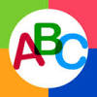 ABC – Letter names, Letter sounds
(tap gear icon to change activity)

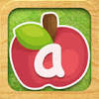 Little Writer – Finger trace/handwriting (letters, numbers, shapes, words)

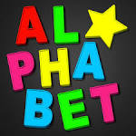 Magnetic ABC – build words with magnet letters (great for anchor word practice and word families)

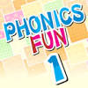 Phonics Fun – Leveled phonics activities: Phonics 1-7 (self-guided through each level)

Popplet - Graphic Organizer (easy WEB builder, can include words and photos)

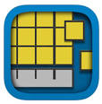 Number Pieces – Math: counting, grouping, building larger numbers, adding/subtracting

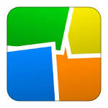or Collage – Graphic Organizer (can include words and photos)

QuickVoice – Record, playback, email voice recordings (optional)

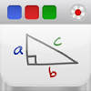 Educreations - Words/Photos/Video (use to make graphic organizers, story responses, writing, math, etc.)

Chatterpix – Take a picture of any object, add a mouth, record voice, playback (great for information and opinion writing)

